**Task 1 :** Create a program that can encrypt and decrypt text using the Caesar cypher , allow users to input a message and a shift value to perform encryption and decryption.

**Input code in Python:**

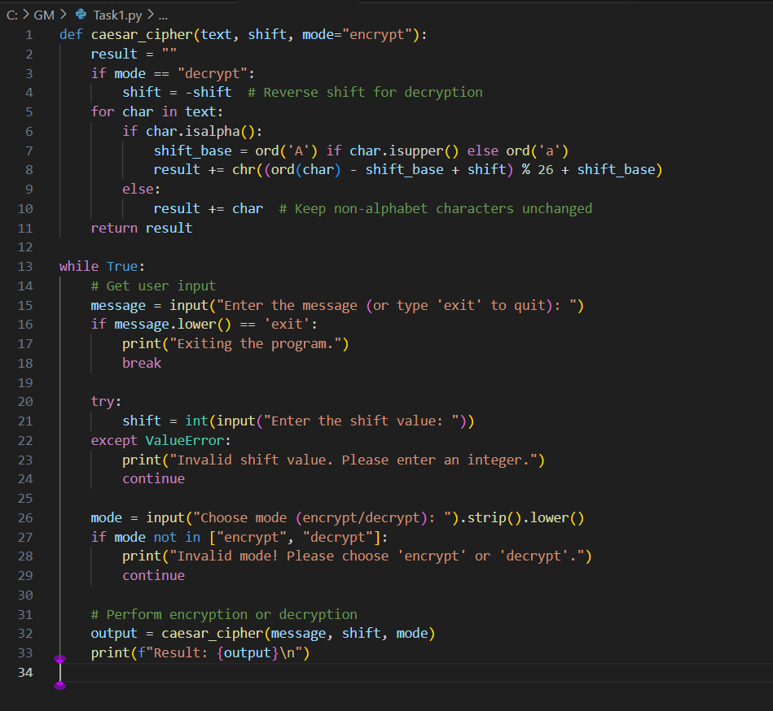

**Output :**

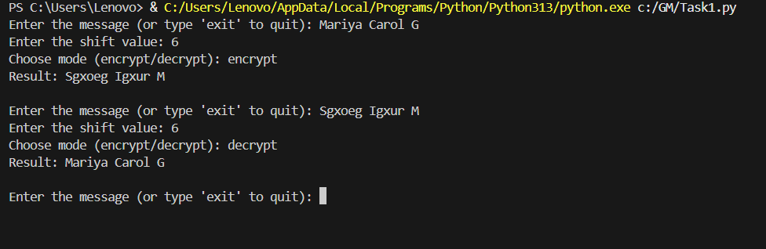

**Working:**

**1. Function Definition: C**aesar cipher

This function is designed to either encrypt or decrypt a given text using the Caesar cipher method, which involves shifting letters in the alphabet by a specified number of positions.​

1. **Parameters:**

* Text: The message you want to process.​
* Shift: The number of positions each letter in the text will be moved.​
* Mode: Determines the operation—either "encrypt" or "decrypt". It defaults to "encrypt" if not specified.​

1. **Process:**

* If the mode is set to "decrypt", the function reverses the shift direction by negating the shift value. This means that instead of moving letters forward in the alphabet, it moves them backward.​
* The function then iterates over each character in the input text:​
* If the character is a letter (either uppercase or lowercase), it calculates its new position by:
* Determining the starting point (shift_base) for uppercase letters ('A') or lowercase letters ('a').
* Calculating the new character by shifting it within the bounds of the alphabet and then converting it back to a character.
* If the character is not a letter (such as numbers, punctuation, or spaces), it remains unchanged.

**Loop Continuation:**

After displaying the result, the program loops back to prompt the user for a new message, allowing continuous encryption or decryption without restarting the program.